**Project Design Phase-I**

**Solution Architecture**

|  |  |
| --- | --- |
| Date | 03 October 2022 |
| Team ID | PNT2022TMID44926 |
| Project Name | Smart Farmer-IOT Enabled Smart Farming Application |
| Maximum Marks | 4 Marks |

**Solution Architecture:**

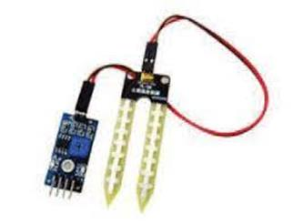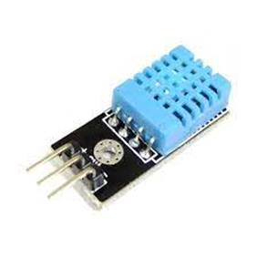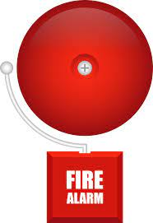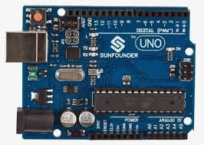

**Temperature and Humidity Sensor**

**Arduino-UNO**

**Soil Moisture**

**Sensor**

**Data base**

**Cloud Server**

**Fire Alarm**

**Power Supply**

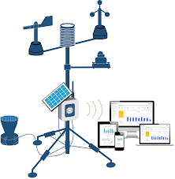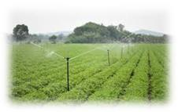

**Farmer**

**Farming**

**Application**

**Field**

**Weather Station**

**(Open Weather API)**